By
Akhil Morisetty
Alex Cheng
Ethan Zhang

FACIAL QUANTUM MIRROR MATCHING
Project Proposal for ECE 445, Senior Design, Spring 2026
TA: Wesley Pang

13 February 2026
Project No. 8
Contents

1. Introduction 2
1.1 Problem 2
1.2 Solution 3
1.3 Visual Aid: 3
1.4 High-Level Requirements List 4
2 Design 5
2.1 Block 5
2.2 Subsystem Overview 5
2.2.1 Display Unit 6
2.2.2 Start Unit 6
2.2.3 Power Unit 6
2.2.4 Backend: Database and Facial Recognition 7
2.3 Subsystem Requirements 7
2.3.1 Display Unit 7
2.3.2 Start Unit 7
2.3.3 Power Unit 8
2.3.4 Backend: Database and Facial Recognition 8
2.4 Tolerance Analysis 8
3. Ethics and Safety 9

1. Introduction

1.1 Problem

Chicago is spending 500 million dollars investing in the development of the Illinois Quantum and Microelectronics Park. Professor Kwait is looking for a viable prototype of a Facial Quantum Matching Mirror that he can show investors to persuade them into creating a more expensive and museum-ready version. Our task is to create a visually appealing and functioning prototype that Professor Kwait can show to investors to eventually add to the Illinois Quantum and Microelectronics Park.

1.2 Solution
We propose a Facial Quantum Matching Mirror, an interactive display device that uses a one-way mirror and facial recognition to reflect a user’s likeness matched with well-known figures in selected categories such as engineers, scientists, or entrepreneurs. When the display is illuminated, the one-way mirror becomes transparent, allowing the user to see the matched character overlaid behind the glass. This creates the illusion that the user is “face-to-face” with a figure who resembles them, combining reflection, computation, and visual storytelling in a single interactive experience.
The system consists of a one-way mirror, a display panel of equal size mounted behind the mirror, a surrounding LED light ring, a camera, local storage, a microcontroller, and a user input button, all integrated within a single frame. When the system is idle, the display remains dark, causing the mirror to behave as a reflective surface so the user sees only their own reflection.
Upon pressing the button, the user selects a category, and the system is activated. The microcontroller triggers visual feedback through the LED ring and commands the camera to capture an image of the user. This image is processed by the facial recognition backend, which identifies the most visually similar individual from the selected category. The result index is returned to the microcontroller, which retrieves the corresponding image from local storage and displays it on the screen.

1.3 Visual Aid:

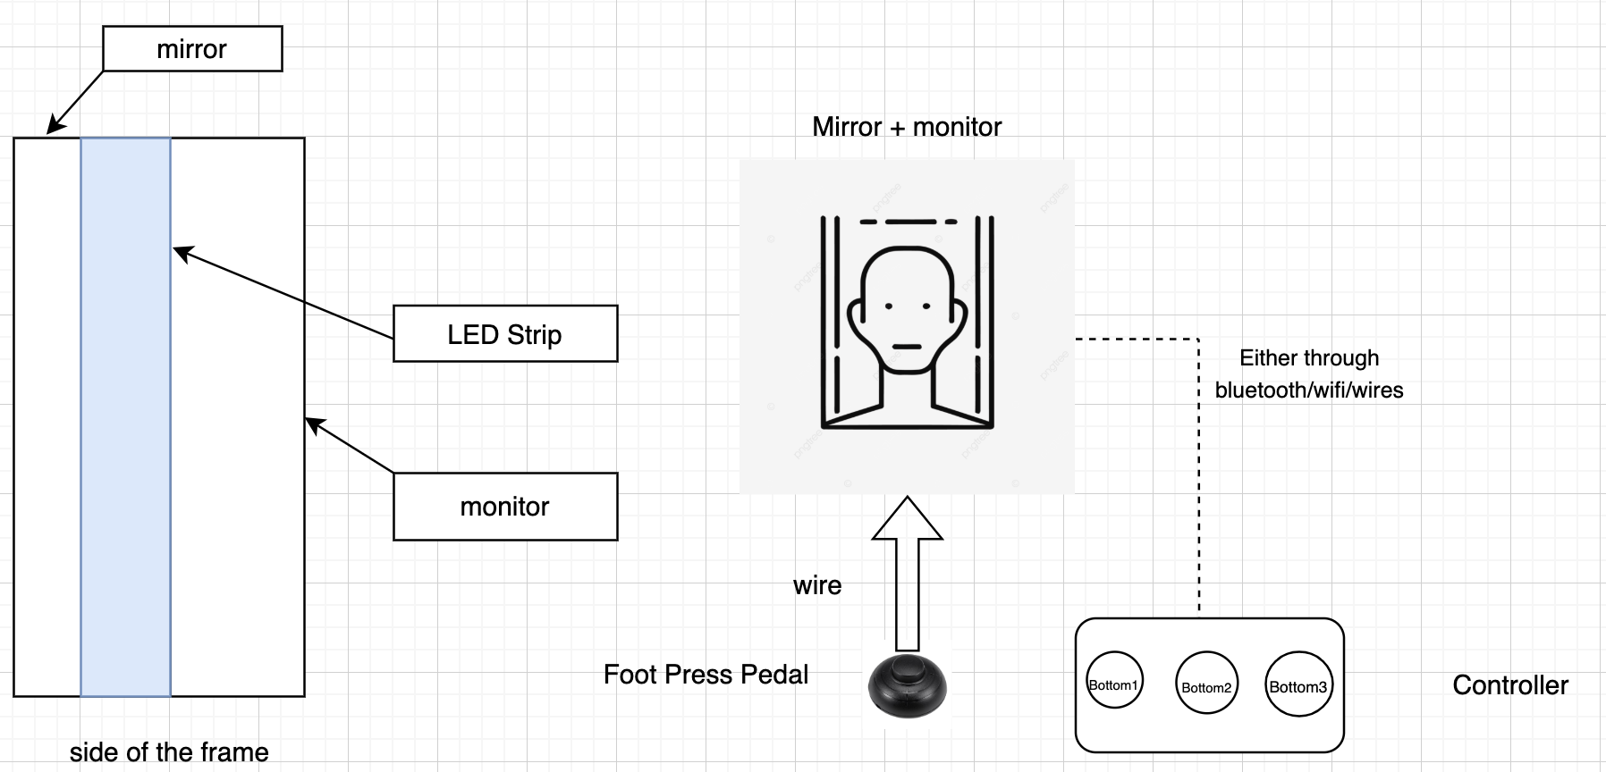

1.4 High-Level Requirements List
- The system should complete the full single-user interaction cycle (LED illumination -> image capture -> facial matching -> display result) within 20 seconds of user activation
- While the monitor is not displaying anything, the mirror should have 70% reflectivity and give the visual effect of a mirror, and when the monitor is on, the monitor screen should be visible even under 30% reflectivity.
- The facial recognition model should return a visually accurate match that achieves at a minimum an 85% accuracy compared to a baseline recognition. (As of right now, we believe baseline recognition should be a group of 3 or more human TAs)

2 Design

2.1 Block

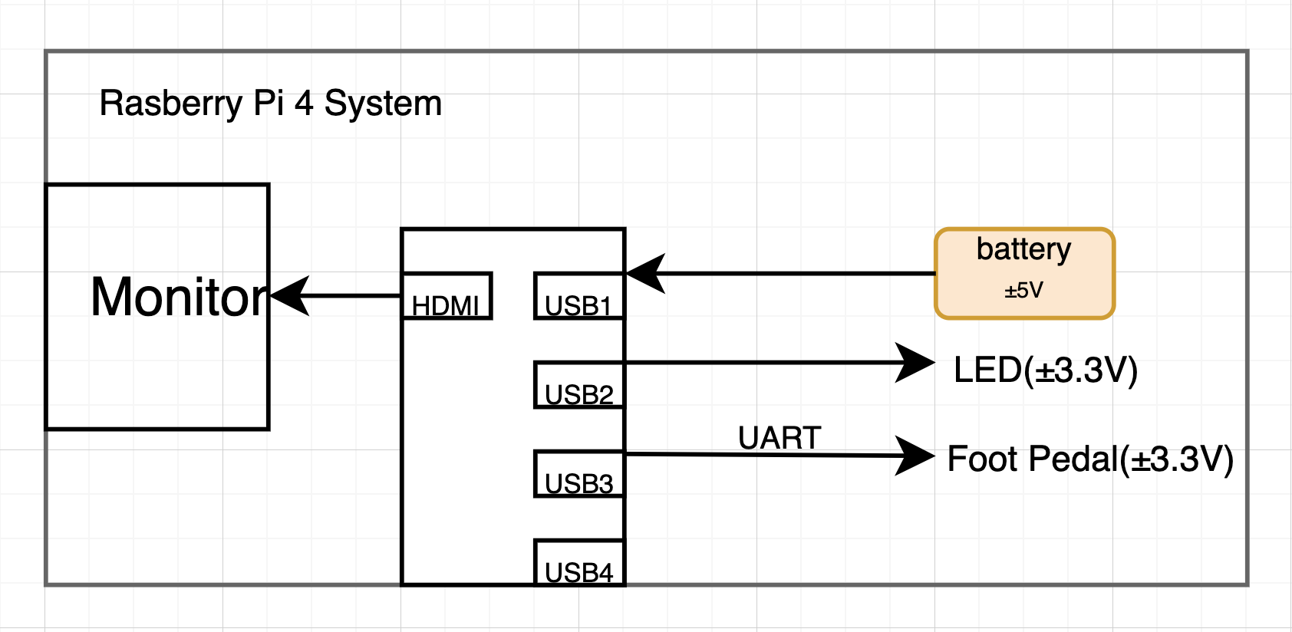
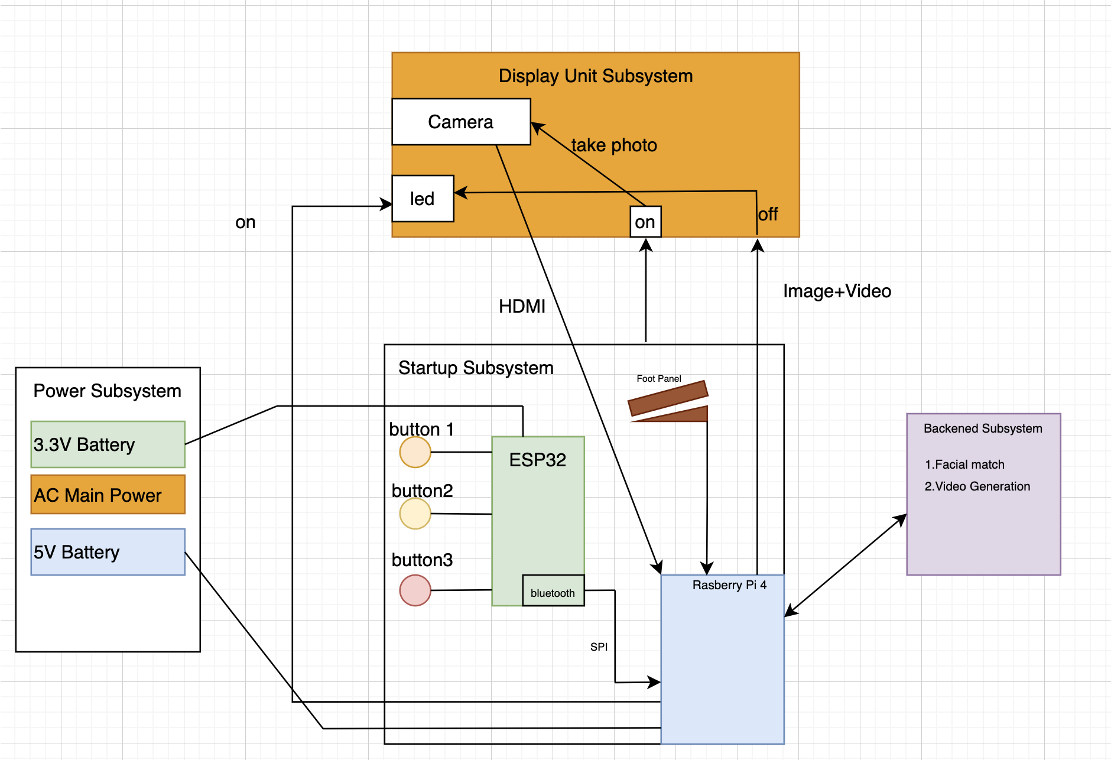

2.2 Subsystem Overview

2.2.1 Display Unit
This subsystem serves as the presentation and capture layer of the smart mirror. It uses an onboard camera to capture a photo of the person standing in front of the mirror, and a monitor behind a two-way mirror to render the user experience (UI prompts, loading screens, images, and optional video). During idle mode, the monitor remains black, so the mirror looks fully reflective like a normal mirror. When the user presses the start button, the display transitions to a loading interface, and the LEDs will be activated to indicate startup, while the backend subsystems process the captured image and return a match. Once processing completes, the monitor displays the selected quantum scientist/engineer/entrepreneur (and any associated content), giving the mirror the appearance of an interactive digital mirror. The LED will be receiving control signals from the Startup Unit, as it will include the system microcontroller. These LEDs will be mounted around the frame of the mirror to ensure high visibility and enhance the overall user experience.

2.2.2 Startup Unit
This subsystem focuses on the start of the entire process for the project. The participant begins the process of using the mirror by choosing options from a set of buttons available to them. Moreover, there will be a pressure plate for the participant to stand onto which sends a signal to the buttons to begin taking the input for sending. The participant will have the option of selecting the quantum category that they want, and starting the camera/scan process with another button. The participant has control over when they are interested in and when they start the process. The button will be attached to the frame of the mirror as a part of a microcontroller on a pcb, where, when the category is selected through the buttons, the microcontroller sends a signal to the computer backend for which category to filter for the face matching. The system microcontroller organizes and communicates between all the other subsystems in the project. All of the logic and transmission of data is handled by this subsystem. Moreover, the software component of the projects sends data back and forth between the microcontroller and itself. The system microcontroller is the overarching subsystem in the project, which essentially plays a role in every component of the solution. The microcontroller also uses its Bluetooth capabilities to communicate with the Raspberry Pi, sending and receiving data.

2.2.3 Power Unit
The power unit powers all of the components within the project. Our power unit will power the monitor, LEDs, and microcontroller. The control pad/startup button will be powered by a three-volt battery. The Raspberry Pi power module will be used to power specifically the Raspberry PI which has the backend software programmed onto it. The pressure sensor, which is part of the startup button subsystem, will have its own battery as well. The power unit for the monitor, LEDs on the display, and the microcontroller will be attached to the back of the frame.

2.2.4 Backend: Database and Facial Recognition
This subsystem receives the captured user image from the Logitech camera and the selected category, computes a face embedding from that image using a pretrained and possibly fine-tuned recognition model. Those embeddings will then be compared to a local database of precomputed embeddings. The backend should return the closest matching match ID to the Raspberry Pi.

2.3 Subsystem Requirements

2.3.1 Display Unit
The display unit directly contributes to the high-level requirements because the monitor and LEDs are what will be moving through the different states in the first high-level requirement. Moreover, the camera on the display unit is what is taking the image for the image processing and matching listing in the second high-level requirement.
- The camera on the display unit must be able to capture an image of the participant's head in < 3s of activation
- The display unit must be reflective like a normal mirror while it is idle and on standby
- The LEDs must be visible and indicate a state of activation within 200ms of foot pedal activation

2.3.2 Startup Button
The startup button directly contributes to the high-level requirements because it provides the primary input from the participant and serves as the activation of the mirror, going through different states and resulting in an output to the user. The microcontroller directly contributes to the high-level requirements because it serves as a coordination between the buttons and the Raspberry Pi, which initiates the activation cycle to begin.
- The startup mechanism should register a valid activation signal within < 50ms of user foot contact
- The startup mechanism should correctly detect activation in > 95% of presses during a 100-press test
- The microcontroller system must reliably receive user input signals from buttons and forward valid state data to the Raspberry Pi processing unit without loss in < 100 ms
- The microcontroller system must boot and enter operational state automatically when powered up without manual operations, and be able to operate continuously for 2 hours without communication failure or reset

2.3.3 Power Unit
The power unit subsystem provides power to two major components: the monitor and the Raspberry Pi.
- The power unit must safely supply a stable 3.3 volts to our ESP-32 Microcontroller during peak usage
- The power unit must provide > 2 hours of continuous operation on a single charge at 3.3 V battery voltage

2.3.4 Backend: Database and Facial Recognition
The backend: database and facial recognition subsystem performs all of the image processing and image matching to result in an output on the mirror and a matched image of the participant.
- The facial recognition system should return a match result within 10 seconds of image capture
- The system should achieve > 85% top-match accuracy per category using a defined validation image set
- The database should correctly store and retrieve records with a near 100% success rate

2.4 Tolerance Analysis
An important aspect of the design that poses a risk to the successful completion of the project is how the two-way mirror operates. If the mirror operates successfully, the mirror should act like a reflective mirror when the system is idle, and when the system changes states, the mirror should be transparent to display the output image. Depending on various lighting conditions and other variable factors, the mirror poses a risk of not acting correctly for the design.

Optical Tolerance Analysis:
L = Lux of the environment that the mirror is placed in
R = mirror reflectance from the human perspective
T = mirror transmittance from the human perspective
B = brightness of the monitor
p = effective reflectance of the mirror
K = contrast factor

In our case, we plan to find a 70% reflective piece of glass, use a monitor with a minimum of 350 cd/m^2, and place our system in replicable museum lighting, which can be equated to bright indoor lighting. We are also going to assume the mirror will be reflecting clothes, skin, and interior building items under average indoor circumstances. K is a contrast factor that means how many times brighter the display is than the reflection for the users to be comfortable seeing the content on the monitor. Thus our variables become:

L = 500 lux | R = 0.7 | T = 0.3 | B = 350 cd/m^2 | p = 0.3 | K = 3

Since our glass will be 70% reflective, when the monitor is in idle state, there wont be any issues with the glass acting as a mirror. The hard part is determined when the monitor is at
350 cd/m^2 brightness into a 30% transmittance. For the monitor to be visible from the human perspective we need:

L-ambient = (L * p) / pi = (500 * 0.3) / pi = 47.7 cd/m^2
L-display >= (L-ambient * K * R) / T

L-display >= (47.7 * 3 * 0.7) / 0.3 = 333.9 cd/m^2

This indicates to us that in order to have our monitor be visible with a contrast factor of 3 under 500 lux lighting conditions, we need a monitor that has a brightness specification of around 340 cd/m^2. Obviously, the luminance of the environment, contrast factor, reflectivity, and transmittance will not be exactly similar to our numbers, but a rough estimate guarantees us that we need to find a monitor with a minimum 300 cd/m^2 brightness and glass with maximum 70% reflectivity.

3. Ethics and Safety

In terms of ethical considerations, our largest concerns are data privacy with our users due to image capturing, algorithmic fairness amongst all demographics of people, and informed content about our matched famous quantum engineers, scientists, and entrepreneurs. We are committed to enforcing IEEE Principle 1 by ensuring that all users who allow our project to capture a facial image of themselves will not have their private data corrupted, misused, or stored for possible leakage. Immediate deletion and local processing will ensure that captured images of users will maintain the shortest possible lifespan. Algorithmic fairness will require us to extract a diversified database that uses honest and unbiased vector embeddings. In terms of informed content, we are determined to ensure that we represent the famous quantum engineers, scientists, and entrepreneurs with truthful and accurate information about their past accomplishments and history.
From a safety perspective, our design must address a multitude of hazards that include but are not limited to electrical, physical, and optical risks inherent after installation. All electrical components will comply with requirements for proper grounding, protection, and sizing. We will also ensure that our two-way mirror will be constructed from tempered or laminated safety glass meeting the standards to prevent dangerous shards in the case of breakage. LED lighting will be limited to comfortable brightness levels, and flash patterns will avoid the possible frequency ranges that can cause human problems.
In support of Chicago’s $500 million investment into the Illinois Quantum and Microelectronics Park, we are dedicated to providing a positive, fair, and historically accurate societal impact by providing users with inspiring but accurate information. We are also committed to maintaining an electrically efficient and long-lasting product that will minimize the environmental impacts of our project. As required by ACM Principle 1.1, we want to feature diversity in our response matches because our mirror serves as an accessible tool to help people feel and understand the contributions to society that past quantum scientists, engineers, and entrepreneurs have fulfilled.

